Appendix C
MHPG Environmental Review
The Montana Historic Preservation Grant (MHPG) Program is a state action subject to the Montana Environmental Policy Act (MEPA). All applicants must follow the environmental review process to determine a finding level, discuss the project and finding level at a public meeting, and make a final determination. The following outlines the environmental review process that must be completed by the applicant.
For detailed information on MEPA, see A Guide to the Montana Environmental Policy Act, or A Citizen’s Guide to Public Participation in Environmental Decision Making at: https://leg.mt.gov/committees/interim/past-interim-committees/2017-2018/eqc/montana-environmental-policy-act/

The Environmental Review Process

1. Designate an Environmental Certifying Officer (ECO):
This individual will be responsible for ensuring the environmental review is completed and for signing the final environmental determination. The officer for a local government would be the Chief Executive Officer. The officer for for-profits or non-profits would be the owner/CEO or executive director, respectively. An Authorized Representative may complete the environmental review process so long as the environmental certifying officer signs all relevant documents.

2. Determine and review the proposed scope of work:
Clearly define the proposed scope of work for the proposed project and the activities involved. Consider the larger effects of the entire project, not just of the portion for which MHPG funds would be directed. For example, an application for climate control systems for a museum expansion with new construction should consider the potential environmental impacts of the entire expansion. Identify any agencies or groups which may have a vested interest in the project or from whom any licenses or permits are required.

3. Determine if the project is considered Exempt from MEPA review:
MEPA specifies three different levels of environmental review, based on the significance of the potential impacts. The levels are: (1) exempt or excluded from MEPA review; (2) environmental assessment (EA), and (3) environmental impact statement (EIS). Due to the nature of the project types, most MHPG projects will fall under Exempt or Excluded. Projects seldom require an EIS, and if this level is anticipated it is recommended that applicants contact Commerce staff.

Statutory or Categorical Exemptions
The following types of actions are statutorily exempt from MEPA review under ARM 8.2.304(5):
- Administrative actions (routine clerical or similar functions, including but not limited to administrative procurement, contracts for consulting services, or personnel actions);
- Minor repairs, operations, and maintenance of existing equipment or facilities;
- Investigation and enforcement; data collection activities; inspection of facilities or enforcement of environmental standards;
- Ministerial actions (in which the agency exercises no discretion and rather acts upon a given state of facts in a prescribed manner);
- Actions that are primarily social or economic in nature and that do not otherwise affect the human environment;
The following types of actions are categorically exempted from MEPA review under ARM 8.2.328(2):
- Projects that will be partially funded by, or for which the applicant must obtain a permit from, a state or federal agency which, by reason of its funding or permitting function, has primary responsibility to consider the environmental impacts of the project under MEPA or the National Environmental Policy Act;
- Activities which do not involve or lead directly to construction, such as planning studies, scientific research and analysis, surveys, or engineering;
- Projects primarily involving the acquisition of capital equipment;
- Projects that involve only minor repairs or rehabilitation to an existing facility, including functional replacement of an existing facility or facility components;
- Projects where the footprint of the proposed structures, pipelines, or other infrastructure would be substantially unchanged from existing conditions, and there is no increase in the population served by the facility; or
- Emergency repairs, reconstruction, restoration, retrofitting, or replacement of an existing facility that is in operation or under construction when damaged and the action:
(i) occurs within the existing facility footprint and in a manner that substantially conforms to the preexisting design, function, and location as the original (which may include upgrades to meet existing codes and standards as well as upgrades warranted to address conditions that have changed since the original construction); and
(ii) is commenced within six months after the date of the emergency.
Projects listed as statutorily or categorically exempt from MEPA review are not required to complete an Environmental Assessment and so do not need to complete the Environmental Checklist (Appendix C-2). If a typically exempt activity may cause significant public controversy related to its effect on the human environment or may affect sensitive cultural or environmental resources, proceeding with an EA is advised.

Environmental Assessment (EA)
An EA is a written analysis of a proposed action to determine whether an EIS is required or is needed to serve one or more of the other purposes described in ARM 8.2.304(2). Normally, a thoroughly completed Environmental Checklist and responses to the six questions contained in the Environmental Review Form (see below) will suffice as the draft EA for public review and comment and may then be revised as necessary to constitute the final EA. Anyone authorized to perform work on behalf of the applicant may prepare the draft EA, using all available information and evidence. The applicant’s authorized representative must sign the draft EA, and the final environmental determination must be made by the applicant’s representatives or board. Preparation of an EA ensures the fullest appropriate opportunity for public review and comment on a proposed action, including alternatives and planned mitigation, and examines and documents the effects of a proposed action on the quality of the human environment. The EA also allows the project proponent to determine the need to prepare an EIS through an initial evaluation and determination of the significance of impacts associated with a proposed action.
In addition, an applicant may prepare an EA whenever the proposed action is one that might normally require an EIS, but the significant effects of the project appear to be mitigated below the level of significance through design, enforceable controls, and/or conditions imposed by the agency or other government agencies. For an EA to suffice in this instance, the applicant must determine that all of the impacts of the proposed action have been accurately identified, that they will be mitigated below the level of significance, and that no significant impact is likely to occur. The applicant may not consider compensation for purposes of determining that impacts have been mitigated below the level of significance.
An EA is a public document and may be inspected upon request. Any person may obtain a copy of an EA by making a request to the applicant. The applicant is responsible for providing public review of an EA as necessary to match the complexity and seriousness of environmental issues associated with a proposed action and the level of public interest in the action. Methods of accomplishing public review include publishing a news release or legal notice to announce the availability of an EA, summarizing its content and soliciting public comment; holding public meetings or hearings; maintaining mailing lists of persons interested in a particular action or type of action and notifying them of the availability of EAs on such actions; and distributing copies of EAs for review and comment. The applicant is responsible for determining appropriate methods to ensure adequate public review on a case-by-case basis.
The applicant shall consider all substantive comments received in response to a draft EA and decide, at a public meeting, that either:
- An EIS is necessary;
- The EA did not adequately reflect the issues raised by the proposed action and must be revised; or
- An EIS is not necessary and make a final decision on the proposed action (executing the contract with Commerce to receive Montana Historic Preservation Grant Program funds for the grantee’s project).

Any time the applicant proposes substantial changes to the project affecting the original EA, the grant recipient must repeat its environmental review for the revisions to the project, assuring the environmental impacts of the revised project are adequately identified, addressed by the grantee, and any necessary public review provided. When completed, the applicant must follow the original process and again provide environmental documents to Commerce.

Environmental Impact Statement (EIS)
An EIS is required whenever an EA indicates that an EIS is necessary, or an applicant proposes an action that may significantly affect the quality of the human environment (a “major action”). If there is a Finding of Significant Impact, immediately contact Commerce for further guidance. Commerce will work directly with the grantee to determine a course of action for fulfillment of the environmental requirements.

4. Proceed with the Public Process:
Public involvement is an important part of the environmental review process. All applicants must hold a public meeting regardless of the expected level of review. The meeting can be a stand-alone event or included on the agenda of another meeting such a Council or Board meeting, or public presentation about the proposed project. It is important the public is made aware or the meeting and has a reasonable opportunity to attend.
When advertising for a public meeting, applicants should follow their standard processes for engaging the public and should make efforts to ensure the public is made aware of the public meeting. Posting on Facebook, on the applicant’s website, and placing ads in the local paper are all ways of ensuring the public is made aware of the meeting. A sample Ad is provided in Appendix C. Advertisements should include;
- A description of the project and reason for the meeting,
- The name the applicant,
- The time and location of the meeting,
- Be posted at least 48-72 hours in advance

Public meetings should be held at a time and place that facilitates public participation. Holding the meeting at the proposed project site when feasible or at publicly accessible locations such as the library, City Hall, or County Courthouse is encouraged.
During the public meeting please do the following;
- Provide an overview of the proposed project, alternatives, and the preliminary environmental finding.
- Accept public comments regarding the project and environmental process.
- Respond to any comments which can be easily addressed within the meeting timeframe. Including a break within the meeting agenda to allow time to develop responses is suggested.
- Make a final environmental determination. If, after public comment, additional time to respond to comments is needed, or that an EA is needed, proceed accordingly and schedule a second public meeting.
- Take meeting minutes to record all comments and items discussed.

If comments cannot be easily addressed within the public meeting, allow time to respond to comments and schedule a second public meeting. Some public comments may lead to changes to the proposed project to mitigate adverse effects or improve the project. At this second meeting, respond to all comments from the previous meeting, and repeat the public process.
In some cases, a project which was initially thought to be Exempt will require completing an Environmental Assessment to fully address public comments and concerns. This typically happens when the preliminary determination is not in line with the full scope of the project, or when there is significant public controversy over the proposed project.

5. Make a Final Environmental Determination:
Once the environmental process is complete and any relevant public comments addressed, make a final environmental determination of the proposed projects level of review. For MHPG projects the level will typically be Exempt or Environmental Assessment. If after completing an EA the project is likely to require preparing an Environmental Impact Statement (EIS), consult Commerce staff immediately. The need for an EIS is very unlikely with MHPG projects.

6. Complete the Environmental Review Form (Appendix C-1):
The Environmental Review Form (Appendix C-1) will provide a summary of the proposed project, the environmental determination level, and detail the public process that was followed to arrive at the final determination. The form must be signed by the Environmental Certifying Official (ECO). An authorized representative may assist in completing the form and environmental review, in which case both the representative and ECO should sign the Environmental Review Form.

7. ECO signs resolution certifying the Environmental Determination:
In addition to the Environmental Review Form applicants must sign a resolution certifying the final Environmental Determination. The ECO must sign the resolution. Sample resolutions for governmental and non-governmental applicants are available on the MHPG Program website for both Exempt and Environmental Assessment determinations.

8. Submit all documents to Commerce along with application:
Submit the completed Environmental Review to Commerce. All documents should be submitted with the MHPG application. A complete environmental Review must include;
- Environmental Review Form (Appendix C-1),
- Resolution to Accept Determination,
- Documentation of public process including meeting minutes,
- Supporting environmental documentation and;
- Environmental Review Checklist (Appendix C-2) ---
  - FOR ENVIRONMENTAL ASSESMENT PROJECTS ONLY

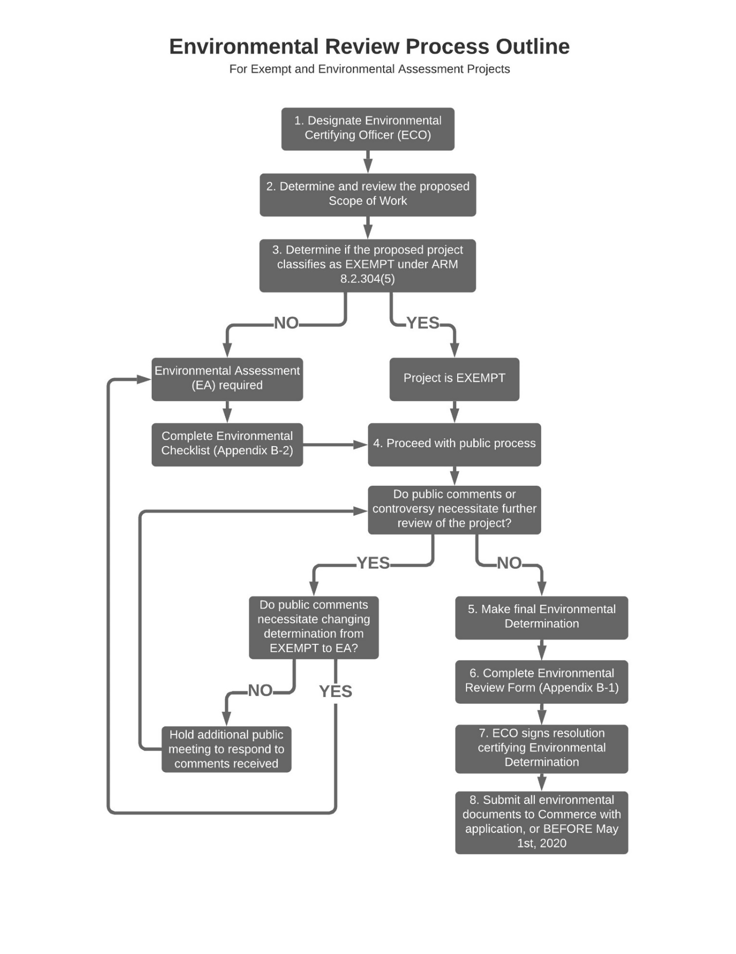

Additional Environmental Considerations

MHPG applicants are responsible for compliance with all applicable state environmental requirements. Some of the other state environmental requirements that may apply to Montana Historic Preservation Grant Program projects include:
- Stream Protection Act, Title 87, Chapter 5, Part 5, MCA

- Montana Solid Waste Management Act, Title 75, Chapter 10, Part 2, MCA

- Clean Air Act of Montana, Title 75, Chapter 2, MCA

- Water Quality Act, Title 75, Chapter 5, MCA

- Public Water Supplies, Distribution and Treatment, Title 75, Chapter 6, MCA

- Floodplain and Floodway Management, Title 76, Chapter 5, MCA

- The Montana State Antiquities Act, Title 22, Chapter 3, MCA

- The Montana Sage Grouse Habitat Conservation Program and Conservation Strategy, Executive Orders 10-2014 and 12-2015 and Chapter 445, Laws 2015 (SB 261) https://sagegrouse.mt.gov/

Some of the environmental permits that may be required on your project from other state agencies include the following:
- Asbestos Control Program – contact the Department of Environmental Quality (DEQ).

- Montana Stream Protection Act (SPA 124 Permit) – contact the Montana Department of Fish, Wildlife and Parks at 444-2449.

- Montana Floodplain and Floodway Management Act (Floodplain Development Permit) – contact the Montana Department of Natural Resources and Conservation at 444-0860 or the local floodplain administrator.

- Federal Clean Water Act (404 Permit) – contact the U.S. Army Corps of Engineers in Helena at 441-1375.

- Short-Term Water Quality Standard for Turbidity (318 Authorization) – contact the Montana Department of Environmental Quality at 444-3080.

- Montana Water Use Act (Water Right Permit and Change Authorization) – contact the Montana Department of Natural Resources and Conservation at 444-6667 or the local DNRC Water Resources Regional Office. A useful website regarding water rights can be found at http://www.dnrc.mt.gov/wrd/water_rts/default.asp.

- Stormwater Discharge General Permits and/or Montana Pollutant Discharge Elimination System (MPDES Permit) – contact the Montana Department of Environmental Quality at 444-3080.

- Please check the DNRC website for a copy of “A Guide to Stream Permitting in Montana.” Their web address is http://dnrc.mt.gov/permits/stream_permitting/default.asp.

- Cultural Resource Survey – You may need to perform a cultural resource survey for your project. The State Historic Preservation Office (SHPO) can be reached at 444-7715 for more information. There is guidance for consulting with SHPO at http://mhs.mt.gov/shpo/archaeology/consultingwith.asp.

Appendix C-1
Environmental Review Form

On a separate piece of paper, please answer the following as they apply to your proposed project:

- Alternatives: Describe reasonable alternatives to the project.

- Mitigation: Identify any enforceable measures necessary to reduce any impacts to an insignificant level.

- Is an EA or Environmental Impact Statement (EIS) required? Describe whether or not an EA or EIS is required and explain in detail why or why not.

- Public Involvement: Describe the process followed to involve the public in the proposed project and its potential environmental impacts. Identify the public meetings -- where and when -- the project was considered and discussed, and when the applicant approved the final environmental assessment.

- Person(s) Responsible for Preparing: Identify the person(s) responsible for preparation of this checklist.

- Other Agencies: List any state, local, or federal agencies that have over-lapping or additional jurisdiction or environmental review responsibility for the proposed action and the permits, licenses, and other authorizations required; and list any agencies or groups that were contacted or contributed information to this Environmental Assessment (EA).

(1) Authorized Representative, Title Date
(Name of) Applicant

(2) Authorized Representative

Date: ______________________________

* If an authorized representative (1) completes the checklist and this form, a executive of the applicant (2) must also sign authorizing acceptance of the review process. Explanation or statement of how/why that representative was authorized should also be included.

Appendix C-2
Environmental Review Checklist

The applicant must include a completed Environmental Review Checklist and Environmental Review Form, if the appropriate environmental level is determined, with MHPG application materials.

NAME OF PROJECT:
PROPOSED ACTION:
LOCATION: | ________________________________ , Montana

Key Letter:
N: No Impact; B: Potentially Beneficial; A: Potentially Adverse; P: Approval/Permits Required; M: Mitigation Required
PHYSICAL ENVIRONMENT
Key | 1 | Soil Suitability, Topographic and/or Geologic Constraints (e.g., soil slump, steep slopes, subsidence, seismic activity)
 |  | Response and source of information:
Key | 2 | Hazardous Facilities (e.g., power lines, hazardous waste sites, acceptable distance from explosive and flammable hazards including chemical/petrochemical storage tanks, underground fuel storage tanks, and related facilities such as natural gas storage facilities & propane storage tanks)
 |  | Response and source of information:
Key | 3 | Effects of Project on Surrounding Air Quality or Any Kind of Effects of Existing Air Quality on Project (e.g., dust, odors, emissions)
 |  | Response and source of information:
Key | 4 | Groundwater Resources & Aquifers (e.g., quantity, quality, distribution, depth to groundwater, sole source aquifers)
 |  | Response and source of information:
Key | 5 | Surface Water/Water Quality, Quantity & Distribution (e.g., streams, lakes, storm runoff, irrigation systems, canals)
 |  | Response and source of information:
Key | 6 | Floodplains & Floodplain Management (Identify any floodplains within one mile of the boundary of the project.)
 |  | Response and source of information:
Key | 7 | Wetlands Protection (Identify any wetlands within one mile of the boundary of the project.)
 |  | Response and source of information:
Key | 8 | Agricultural Lands, Production, & Farmland Protection (e.g., grazing, forestry, cropland, prime or unique agricultural lands) (Identify any prime or important farm ground or forest lands within one mile of the boundary of the project.)
 |  | Response and source of information:
Key | 9 | Vegetation & Wildlife Species & Habitats, including Fish and Sage Grouse (e.g., terrestrial, avian and aquatic life and habitats)
 |  | Response and source of information:
Key | 10 | Unique, Endangered, Fragile, or Limited Environmental Resources, Including Endangered Species (e.g., plants, fish, sage grouse or wildlife)
 |  | Response and source of information:
Key | 11 | Unique Natural Features (e.g., geologic features)
 |  | Response and source of information:
Key | 12 | Access to, and Quality of, Recreational & Wilderness Activities, Public Lands and Waterways, and Public Open Space
 |  | Response and source of information:
HUMAN ENVIRONMENT
Key | 1 | Visual Quality – Coherence, Diversity, Compatibility of Use and Scale, Aesthetics
 |  | Response and source of information:
Key | 2 | Nuisances (e.g., glare, fumes)
 |  | Response and source of information:
Key | 3 | Noise -- suitable separation between noise sensitive activities (such as residential areas) and major noise sources (aircraft, highways & railroads)
 |  | Response and source of information:
Key | 4 | Historic Properties, Cultural, and Archaeological Resources
 |  | Response and source of information:
Key | 5 | Changes in Demographic (population) Characteristics (e.g., quantity, distribution, density)
 |  | Response and source of information:
Key | 6 | General Housing Conditions - Quality, Quantity, Affordability
 |  | Response and source of information:
Key | 7 | Displacement or Relocation of Businesses or Residents
 |  | Response and source of information:
Key | 8 | Public Health and Safety
 |  | Response and source of information:
Key | 9 | Lead Based Paint and/or Asbestos
 |  | Response and source of information:
Key | 10 | Local Employment & Income Patterns - Quantity and Distribution of Employment, Economic Impact
 |  | Response and source of information:
Key | 11 | Local & State Tax Base & Revenues
 |  | Response and source of information:
Key | 12 | Educational Facilities - Schools, Colleges, Universities
 |  | Response and source of information:
Key | 13 | Commercial and Industrial Facilities - Production & Activity, Growth or Decline.
 |  | Response and source of information:
Key | 14 | Health Care – Medical Services
 |  | Response and source of information:
Key | 15 | Social Services – Governmental Services (e.g., demand on)
 |  | Response and source of information:
Key | 16 | Social Structures & Mores (Standards of Social Conduct/Social Conventions)
 |  | Response and source of information:
Key | 17 | Land Use Compatibility (e.g., growth, land use change, development activity, adjacent land uses and potential conflicts)
 |  | Response and source of information:
Key | 18 | Energy Resources - Consumption and Conservation
 |  | Response and source of information:
Key | 19 | Solid Waste Management
 |  | Response and source of information:
Key | 20 | Wastewater Treatment - Sewage System
 |  | Response and source of information:
Key | 21 | Storm Water – Surface Drainage
 |  | Response and source of information:
Key | 22 | Community Water Supply
 |  | Response and source of information:
Key | 23 | Public Safety – Police
 |  | Response and source of information:
Key | 24 | Fire Protection – Hazards
 |  | Response and source of information:
Key | 25 | Emergency Medical Services
 |  | Response and source of information:
Key | 26 | Parks, Playgrounds, & Open Space
 |  | Response and source of information:
Key | 27 | Cultural Facilities, Cultural Uniqueness & Diversity
 |  | Response and source of information:
Key | 28 | Transportation Networks and Traffic Flow Conflicts (e.g., rail; auto including local traffic; airport runway clear zones - avoidance of incompatible land use in airport runway clear zones)
 |  | Response and source of information:
Key | 29 | Consistency with Local Ordinances, Resolutions, or Plans (e.g., conformance with local comprehensive plans, zoning, or capital improvement plans)
 |  | Response and source of information:
Key | 30 | Is There a Regulatory Action on Private Property Rights as a Result of this Project? (consider options that reduce, minimize, or eliminate the regulation of private property rights.)
 |  | Response and source of information:

Sample Advertisement for Public Comment and Review of Environmental Review Record

The <Applicant> will hold a public hearing on <date> at <time/location> for the purpose of obtaining comments regarding the environmental review record for the proposed <type> project that will < scope of work>.
At the public hearing the proposed project will be explained, including the purpose and proposed area of the project, activities, budget, possible sources of funding, any costs that may result for local citizens as a result of the project, and a decision will be made on the environmental assessment. All interested persons will be given the opportunity to ask questions and express opinions regarding the proposed project and any environmental impacts.
Comments may be given orally at the meeting or submitted in writing before <date> at <time>.
Anyone wanting to review the environmental review record and project impacts or submit questions and comments should contact <who, how>. Copies of the draft environmental record is available at <where> and will also be available at the public meeting.
<Applicant>

Sample of a Resolution to Accept the Determination that (level of environment finding) is Appropriate for the (applicant, type of project)

WHEREAS, the (Name of applicant) has completed an review to identify potential environmental impacts to the (describe purpose of project);

WHEREAS, the draft Environmental Review Record was made available for public comment and the findings were presented and reviewed at a public meeting;

WHEREAS, no substantive public comment was received, (or public comment was received and responded to);

WHEREAS, The (Name of applicant) has determined that the (type of Project) will not significantly affect the quality of the human environment and accordingly the (Name of Applicant) has determined an Environmental Impact Statement (or Environmental Assessment and EIS if project is Categorical Exclusion); is not necessary;

NOW, THEREFORE, BE IT RESOLVED by the (Council, Board, Commissioners) as follows;

That (Name of Applicant), Montana adopts the final Environmental Determination for the (type of project).

Passes and approved on this date of (date)

Signed: ___________________________________

Name: ___________________________________

Title: ___________________________________

Date: ___________________________________

Attested: ___________________________________

